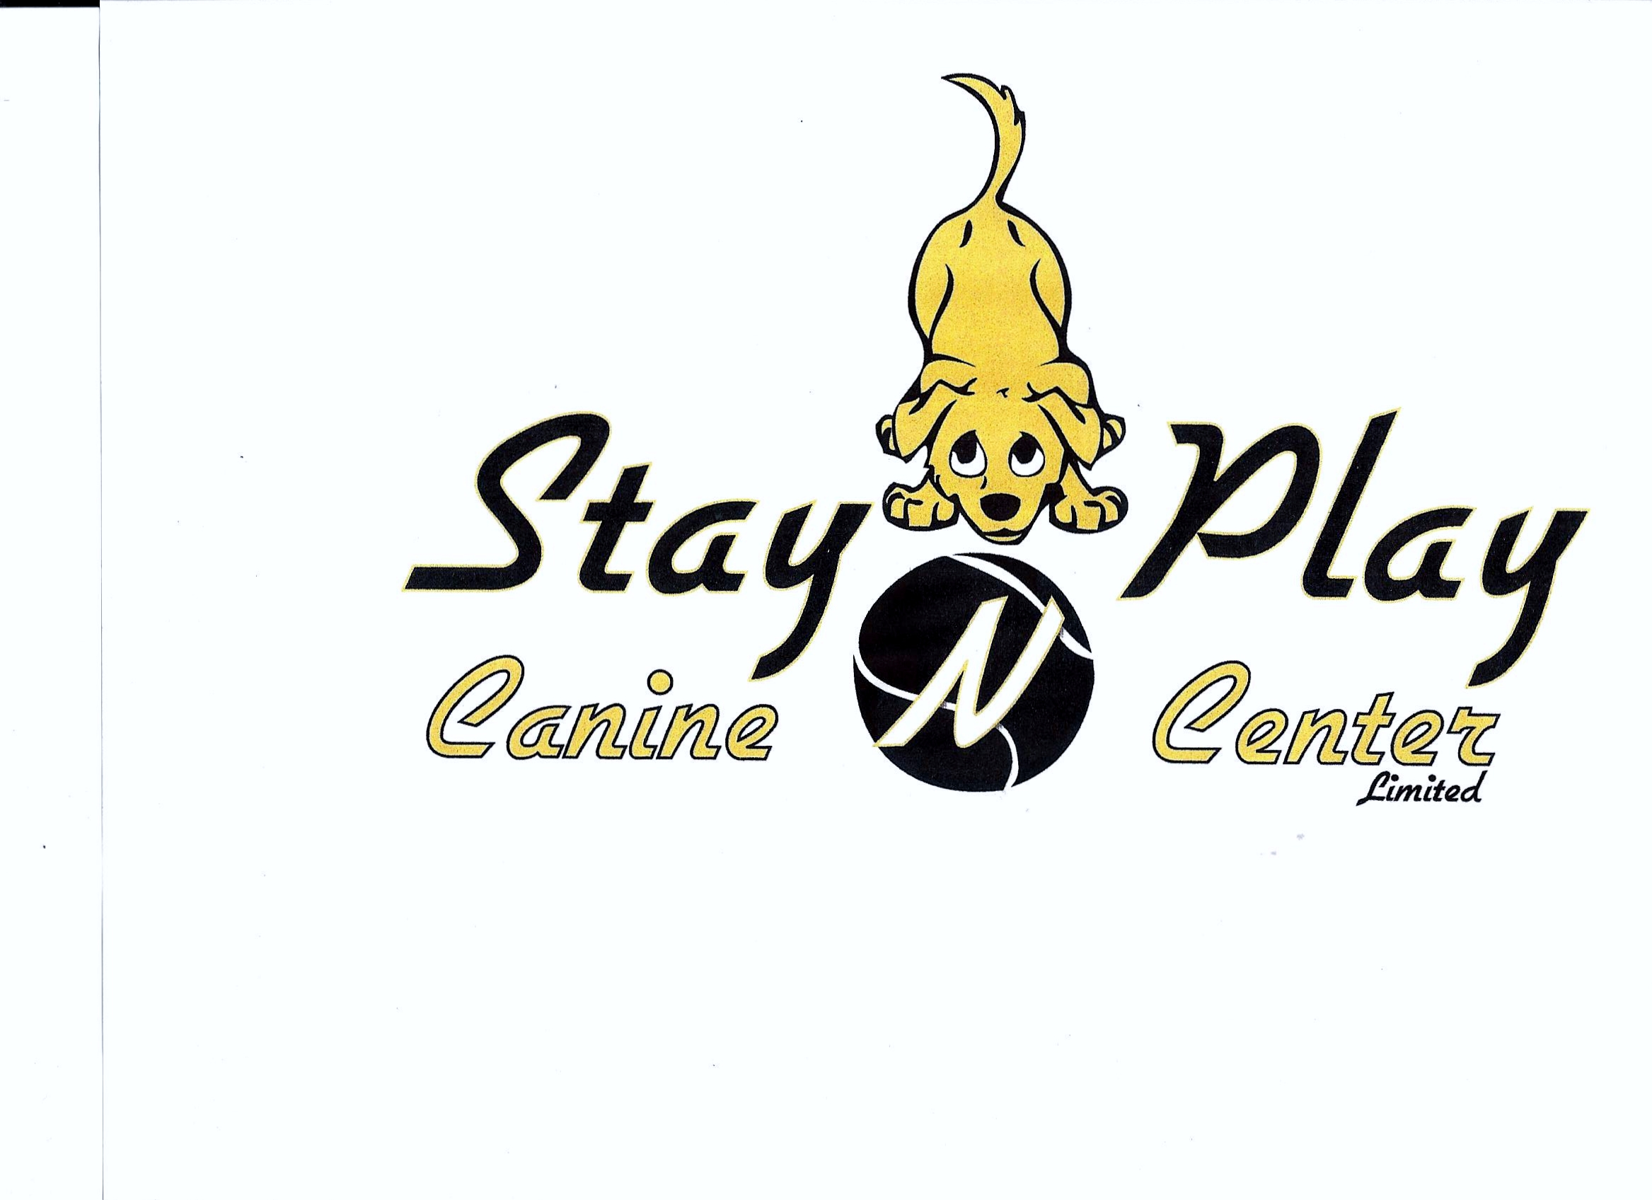

Sanctioned Agility Trial
June 16/17, 2018
Stay N Play Canine Centre
Truro, Nova Scotia
(Outside - Grass)
Judge
Sharon Ransom

Saturday | Sunday
Standard 1  Standard 2  Snooker 1  Jumpers 1  (Running Order)  Masters-Advanced-Starters | Gamblers 1  Standard 3  Steeplechase 1  Jumpers 2  (Running Order)  Starters-Advanced-Masters

LIMITED ENTRY TRIAL
ENTRY CLOSING DATE June 8, 2018

Trial Chair Betty Blackie 902- 895-3141 info@staynplaycaninecentre.ca
Trial Secretary: John MacKinley 902- 865-2316 john.mackinley@ns.sympatico.ca

NOTICE TO EXHIBITORS

- Very Important rule change for 2018*

ALL dogs are required to be re-measured for 2018 in accordance with the new AAC jump heights. These cards are personalized so you must provide your own card at the trial Check In. There are no temporary cards.

All competitors are required to “Check In” and register during our Measurement Time from 7:30 – 8:00 AM.

Competitors can also preregister and avoid the trial day “Check In” by sending a copy of their dog's completed official AAC 2018 Height Card with their trial entry.

If you did not preregister, forgot to request a new card or forgot to bring your new card to the trial, your dog MUST be measured by the judge in order to compete.

Exhibitors, through submission of entry, acknowledge that they are knowledgeable of AAC rules and regulations including, but not limited to, the following:

This event will be held in accordance with the rules and regulations of the Agility Association of Canada (AAC). The obstacles shall be chosen from those described in the current edition of the AAC Official Rules and Regulations and shall conform to AAC specifications.

All breeds and mixed breeds eighteen months of age and older (no exceptions) are eligible to compete. Blind, lame, or aggressive dogs are ineligible as are bitches in season, or dogs suffering from any deformity, injury, or illness that may affect the dog’s physical or mental performance (judge’s discretion).

All dogs must have an AAC Registration Number before their entries will be accepted in an AAC sanctioned trial. The registration form is available at www.aac.ca, General Information, Official Forms. Dogs with numbers pending will be eligible to compete.

No food or other training devices shall be allowed on the course.

All dogs must be under control (i.e. penned, crated, or leashed) when not in the ring. Please take responsibility for your dogs and children. Any exhibitor whose dogs or children create unnecessary disturbances or engage in unsafe or disruptive behaviour may be asked by the Trial Committee to leave the trial site. There will be no refunds for entries if the dog or handler is dismissed from the competition for any reason.

All exhibitors entering this trial are required to work as a volunteer. A workers volunteer schedule will be posted on Saturday and Sunday mornings. Please check the job grid schedule to see what positions you have been assigned each day.

Handlers under the age of 18 are eligible for a 50% discount on their trial entry fees.

Refunds for withdrawing from the trial will not be given for cancellations after the closing date except for bitches in season or injury to a dog (veterinarian certificate required), or handler, which physically prevents them from competing. Refunds requested for any reason will be handled on a case-by-case basis and will be at the sole discretion of Stay N Play.

Veterans DD (Double Drop) is an additional Division on our premium. You need to circle this division on your entry form if you have dropped your dog two jump heights.

Have fun, run safe and run clean!

AAC CLASS DESCRIPTIONS

Starters: Open to dogs that have not earned a Starters title.

Advanced: Open to dogs that have not earned an Advanced title.

Masters: Open to dogs that have earned an Advanced title.

Regular: Dogs will jump standard heights and course times as set by AAC rules.

Specials: Open to all dogs. Course times and jump heights will be as per AAC rules. Please check with the AAC for the rule change that permits a “one time” move between Specials and Regular divisions. Dogs may move from the Specials division to the Veterans division.

Veterans: For dogs 7 years of age or older in the case of dogs who have been competing in Regular classes, for dogs 5 years of age or older who have been competing in the Specials division for a minimum of one year. Once a dog has entered an official trial in the Veterans division, they may no longer compete in the Regular or Specials divisions. Course times and jump heights will be as per AAC rules.

PRIZES

- All classes will receive flat ribbons for 1st, 2nd, 3rd, and 4th.

- Ribbons for Qualifying Runs

OBSTACLE FAMILIARIZATION / WARM-UP AREA

- There will be no obstacle familiarization.

- A warm-up area will be provided as required by AAC rules. The warm-up area is for the use of dogs that are about to run.

ACCOMMODATIONS

Comfort Inn: 12 Meadow Drive, Truro – 902-893-0330

Berry’s Inn: 73 Robie Street, Truro – 902-895-2823

DIRECTIONS to: Stay N Play:

From Veterans Memorial Highway - NS Hwy # 102- take Exit 13 onto McClure's Mills Connector Road towards Wade Road. Turn right onto Willow St (signs for Hilden / Brookfield / Halifax / Millbrook / N S Hwy # 2 ). Turn left onto Blakeney Dr. Take the 1st right onto Crossley Ave.

OFFICIAL TRIAL ENTRY FORM – June 16/17, 2018
(Please use a separate form for each dog)

Name

Address

Town Prov.

Postal Code Phone

E-Mail

Dog Name _________________________ AAC ID #

Dog DOB __________________________ JH ID #__________________

Dog Breed ____________________________________________________

JUMP HEIGHT: 4” 8” 12” 16” 20” 24”

DIVISION: Regular Specials Veterans Veterans DD (Double Drop)

Check the appropriate boxes:
(ST=Starters, AD=Advanced, MA=Masters, JH=Junior Handler)

 | CLASS
 | ST | AD | MA | JH
SATURDAY
Standard 1 |  |  |  |  |  | $15.00
Standard 2 |  |  |  |  |  | $15.00
Snooker 1 |  |  |  |  |  | $15.00
Jumpers 1 |  |  |  |  |  | $15.00
SUNDAY
Gamblers 1 |  |  |  |  |  | $15.00
Standard 3 |  |  |  |  |  | $15.00
Steeplechase 1 |  |  |  |  |  | $15.00
Jumpers 2 |  |  |  |  |  | $15.00
⁮
Stay N Play reserves the right to refuse any entry

- Anyone not in good standing with AAC will not be allowed to enter the trial.

- Cheques in CDN funds only are made payable to Stay N Play and dated no later than the closing date.

- Confirmations will be e-mailed.

Mail entries to:
John MacKinley
1 Rothwell Street
Upper Sackville, Nova Scotia B4E 3C2

AAC Registration Agreement
Note: This agreement must be signed before your dog can participate in this event.

I (we) agree that the club holding this event has the right to refuse this entry for cause which the organizing committee shall deem to be sufficient. In consideration of the acceptance of this entry, the holding of this event and the opportunity to have the dog participate or be judged, I (we) agree to hold the organizing committee, the organization which it represents, including its members, officers and directors, owners of premises upon which the event is held and their employees, harmless from any claim for loss of injury which may be alleged to have been caused directly or indirectly to any person of thing by the act of this dog while in or upon the event premises or grounds or near any entrance thereto, and I (we) personally assume all responsibility and liability for any such claim; and I (we) further agree to hold the aforementioned parties harmless from any claim for loss of this dog by disappearance, theft, death or otherwise, and from any claim for damage or injury to the dog, whether such loss disappearance, theft, damage or injury, be caused or alleged to be caused by the negligence of the parties aforementioned, or by the negligence or any other person, or any other cause or causes. I (we) hereby assume the sole responsibility for and agree to indemnify and same the aforementioned parties harmless from any and all loss and expenses (including legal fees) by reason of the liability imposes by the law upon any of the aforementioned parties for damage because of bodily injuries, including death at any time resulting there from sustained by any person or persons, including myself (ourselves) or on account of damage to property, arising out of or in consequence of my (our) participation in this event, howsoever such injuries, death or damage to property may be caused or may have been alleged to have been caused by negligence of the aforementioned.

Signature:

_____________________________

Date: ________________________________

(Children under 18 must have this agreement signed by parent or guardian)

_

